To: |  | Council
Date: |  | 29 April 2019
Report of: |  | Assistant Chief Executive
Title of Report: |  | To provide Council with the annual partnership update report on the Oxfordshire Children’s Trust.
Summary and recommendations
Purpose of report: |  | To provide members with an update on the work of the Oxfordshire Children’s Trust
Key decision: |  | No
Executive Board Member: |  | Cllr Marie Tidball – Supporting Local Communities
Corporate Priority: |  | Strong Active Communities
Policy Framework: |  | The Children & Young People’s Plan
Recommendation: That Council resolves to:
1. | Note the receipt of the report

Appendices
Appendix 1 | Children and Young people’s implementation plan

Introduction
  - The Children’s Trust Board brings together the public, private and voluntary sectors to improve outcomes for all children and young people who live in the county.
  - The Board's objectives are to ensure that agencies work together effectively and strategically across children’s services.
  - The trust reports to the Health and Wellbeing Board and influences and supports the work of the board to improve outcomes for children and young people and their families.
  - The Children's Trust meets four times a year and in public at least once a year.
  - The voice of children, young people and their families contribute to these arrangements and to decision-making through VOXY (Voice of Oxfordshire Youth) and their representatives attending the Children’s Trust board meetings.

Background – membership and purpose of the Oxfordshire Children’s Trust
  - The purpose of the trust is to:
- Oversee key areas of multi-agency strategic planning for children and young people
- Improve outcomes for children in relation to being successful, keeping safe, staying healthy, and being supported
- Drive the integration agenda where there is evidence that integrated working will improve outcomes for children and young people
- Champion the involvement of children, young people, parents and carers in partnership working with senior managers and politicians
- Ensure the Health and Wellbeing Board and other partnerships are sighted on the key challenges facing children and young people in Oxfordshire.
The Children’s Trust Board Terms of Reference (pdf format, 443Kb).

  - The Chair of the Children's Trust is Councillor Steve Harrod (Cabinet member for Children and Family Services) and the Deputy Chair is Dr Matthew Gaw (Oxfordshire Clinical Commissioning Group).
  - There is one other board seat for a Councillor. This seat represents both the Oxford City council and the other Oxfordshire District Councils on the Trust. Cllr Marie Tidball has held this board seat since July 2017. Oxford City and the other Oxfordshire District Councils’ involvement and engagement in the Trust is supported by the Oxford City Council’s Policy and Partnership Team Manager.
Areas of work that have been reported on and raised at board for 2018/19 are
Achievements in 2018/19
  - In 2018-2019 the board priorities were;
- Children missing out on education
- Social and emotional wellbeing and mental health
- Protecting children from domestic abuse.
  - The voice of children, young people and their families contribute to these arrangements and to decision-making through VOXY (Voice of Oxfordshire Youth) and their representatives attending the Children’s Trust board meetings.
  - These priorities were agreed and supported by the Joint Strategic Needs Assessment, quality and performance data gathering across partnerships and youth engagement events across the county.
  - The City Council’s Children and Young People’s Strategy (CYPS) is highly complementary to the work of the trust and was commended by it. The CYPS shows how we support the delivery of these priorities. The strategy also makes connections between work streams to ensure the most effective use of resource.
  - Oxford City Council has been noted in the CYPP for our strength of partnership working and effort to meet the needs of children and young people across the City.
  - The City’s Youth Ambition Programme has proved very successful; the total budget for the programme has been £240,000 this year. To ensure this investment has the maximum impact, we have worked with the County Council and other partnerships to implement a shared approach to our work with children and young people
  - The aim of Youth Ambition is to build meaningful relationships with disadvantaged young people aged 10-21 years old, (or up to 25 if they have physical or learning difficulties), who are from Oxford’s regeneration areas. They engage with young people through youth voice activities, youth clubs, holiday activities, multi-sports sessions and detached work in a variety of settings. They also work in partnership with other voluntary, community and statutory organizations.
  - A key partnership this year has been the work of the City Impact Zone. This brings together a group of stakeholders from different agencies to focus on improving a particular outcome, or set of outcomes which could be related to health, education or other key metric for children and young people in a given area.
  - This initiative is very much about working across all agencies to look creatively at prevention in a particular geographical area and think through innovative ways that agencies can work together to make a difference to children and young people.
  - One of the two pilot areas has been supporting families in the area of East Oxford and Blackbird Leys where there is a high degree of inequality. By working with residents and across sectors, to strengthen families and create safer communities,
  - We know these inequalities play a role in perpetuating intergenerational disadvantage, given a high incidence of adverse childhood experiences. We will bring a long-term perspective to tackling these issues, building community resilience and working with residents throughout the process.
  - The Community Impact Zone seeks to:
- Secure better outcomes in small localities where outcomes are noticeably less good, identified using cross-partnership data.
- Listen to and work with the local community, especially those whose are voices less often heard, about strengths, challenges and potential solutions.
- Work with the voluntary sector to focus collective effort and resources in small localities where outcomes are noticeably less good, to achieve greatest impact.
- Adapt service delivery by statutory agencies and participating voluntary sector organisations in those small localities to maximise the collaborative impact.
- Use Early Intervention and Collective Impact approaches, supporting all families and individuals within the small locality to be safer and stronger together.

  - Other areas of work that Oxford City are delivering on the Children's Trust priorities are
- Play and Leisure – positive opportunities / preventative services
- Arts Development – Funding Creative Education Partnerships in Cherwell and City
- Parks / Countryside sites
- Provide Funding Pots (small)
- Health / Active lifestyle promotion
- Grants – give out and co-ordinate bids to get funds in
- Affordable Housing – tenancy support
- Community Centres / Outreach / Family support intergenerational work
- Preventative Services
  - Oxford City Council has been represented on the key sub groups of the Children’s Trust throughout the year. This has included influencing, challenging and helping to shape services.
Areas of work that have been raised at the Board, where there were further challenges around performance are:
Be Successful Performance Information: The percentage of placing permanently excluded pupils within the 6-day limit remains low. The remaining two measures are measured annually (Reduce the persistent absence of children subject to a Child in Need plan, and Ensure the attainment of pupils with SEND but no statement or Education Health and Care Plan is in line with the national average) and have been subject to deep dive reviews. Be Healthy Performance Information: The average number of referrals per month to CAMHS has been increasing year on year since 2015/16. Oxfordshire Health Foundation Trust is benchmarking well against CAMHS National Access Trajectory KPI, and is one of the few Trusts meeting the target of 32% of children who need a CAMHS service, being seen. However, there is still a challenge to see all children within 12 weeks. Currently only 25% of children are being seen within the required timeframe. This continues to be rigorously monitored by the Oxfordshire Clinical Commissioning Group.
Be Safe Performance Information: The number of looked after children continues to rise. At the end of Q2 there was an increase to 764 children, compared to 690 at the beginning of April. This is caveated in that Oxfordshire has had historically low levels, additionally there has been a drop in the number of children leaving the care system, rather than a significant increase in the children becoming looked after. Increases have meant that Oxfordshire’s numbers are higher than similar authorities, however they are still lower than the national average. Be Supported Performance Information: VOXY have launched a survey to the youth of Oxfordshire, which will help provide information and assurances around the
‘Be Supported’ area of focus in the Children and Young People’s Plan. It was decided that seeking answers directly from Oxfordshire’s youth would be the best way to measure this area Page 260 of focus. The wording for the questions was taken directly from the plan, to help provide as much information as possible. The survey launched near the end of January, and was live until mid-February, it was shared as widely as possible via members of the Children’s Trust Board, to try and get a good response rate, from a range of demographics, across Oxfordshire’s youth.
Summary of other items discussed by the board
  - Positive work has been taking place in relation to LGBT issues with young people. Training has been delivered by Topaz (an LGBT support group), and an Anti-Bullying Youth Conference, with a focus on LGBT bullying has taken place. This was a partnership event and excellent feedback was received from participants. Despite this good work, it has been identified that there is a lack of provision in LGBT support for young people in the west of Oxfordshire. Further funding is being sought, to be able to reach out further to the West Oxfordshire area and provide support where it is needed.
  - The following diagram shows the connections between the strategic partnerships for young people and Oxford City Council’s Strategy for Children and Young People.
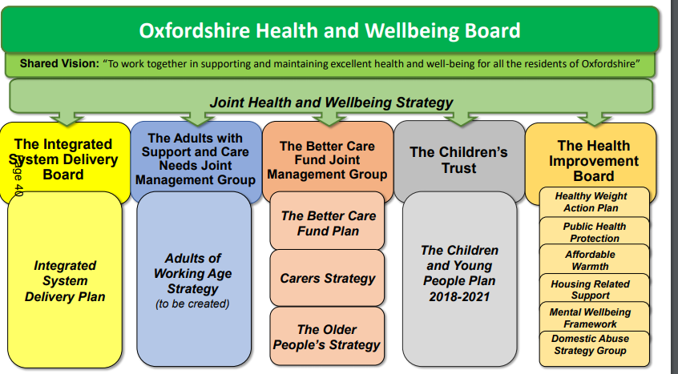

Youth Partnership Board
  - The City Council facilitates a Youth Partnership Board. This board is chaired by a secondary head teacher and is made up from the city, county, health, business, Mind, TVP, OCVA and young people. The City’s Cultural Education Partnership reports into the Youth Partnership Board,
  - The City Council is represented on the Learner Engagement Board, the Strategic Schools Partnership, the Domestic Abuse Strategy Group and the Early Help Starter Group
  - This enables the effective sharing of information to protect the safety of vulnerable children and young people.
  - Community Safety provide partnership oversight of Anti-social Behaviour, Child Exploitation and County drugs Lines, Modern day slavery and we have used the partnership to cascade and inform our own practice in relation to young people’s pathways and access to services.
  - This work has enabled us to achieve best practice in our safeguarding practice in relation to children this year.

Focus for the year ahead
  - The priorities for the Children’s Trust’s work are decided annually by the board and contained within an implementation plan. The implementation plan for 2019/20 can be viewed in Appendix 1.
  - At the last Children’s Trust Board meeting it was agreed that the priorities from 18/19 would continue throughout 19/20 as there was still work to be done in all 3 areas and they remained a priority for young people across Oxfordshire.
  - The Policy and Partnership Team Manager has worked closely with Head of Communities, the youth ambition team and the current portfolio holder to ensure that key priorities of the Children’s Trust and implementation plan align with our own corporate priorities for children and young people in the city. This has involved participating in a task and finish group over a 9 month period to develop and shape the implementation plan. The progress of this work being delivered through the City Council Children’s and young person’s strategy will continue to report into the task and finish group steer, performance measures and children’s trust reporting framework.
  - The City Council will continue to develop and support the work of the Community Impact Zone pilot in East Oxford through the facilitation of the steering group and reporting in the progress, challenges and learning to the children’s trust in partnership with the County.
Supporting the creation of a Learner Engagement Strategy
  - Schools in Oxford and across the county have seen high numbers of persistent absentees compared to national figures and an increasing number of children in receipt of fixed term and permanent exclusions. In response, the County Council is developing a new Learner Engagement Strategy, to which the City Council is providing input, including officer representation on the newly established County-led Learner Engagement Board.
  - The City Council also has officer representation on the independently chaired Oxfordshire Strategic Schools Partnership (OSSP), which brings together representatives of key educational organisations in Oxfordshire to bring strategic oversight and peer-to-peer support for school improvement in the increasingly fragmented state school sector. It is committed to delivering better outcomes for all Oxfordshire learners, and especially those of vulnerable and disadvantaged backgrounds.
  - This year the OSSP prioritised improving attendance and reducing fixed term and permanent exclusions, commissioning a project (Project 8) in The Oxford Academy that has involved experts working with the school to develop strategies and provision for learners with challenging behaviour and social, emotional and mental health (SEMH) needs, based on successful practice developed in primary schools. The focus of the project was year 8 boys at risk of exclusion based on their education history and patterns of exclusions within the school. As the project moves into its second year, it has been seen as successful with exclusion rates reducing and it will be extended to other schools.

Challenges
External Environment and Capacity
  - We continue to see shrinking resources across the public sector alongside increased demand for services and complexity of social issues.
Culture
  - There are still some challenges with strategic ownership and the move toward a partnership approach for the best possible outcomes and impact for young people is crucial.

Report author | Daniella Granito
Job title | Policy and Partnership Team Manager
Service area or department
Telephone
e-mail | dgranito@oxford.gov.uk

